Distributed Real-Time Systems (DRTS)
# Source: AI Source: Provided by: [Data Path: Persons Table -> ID Column: 1, Name_En Column: Motasem Essam] -> From: [ChatGPT] on [1/16/2026]
A Distributed Real-Time System (DRTS) is a type of distributed system in which multiple nodes cooperate to process and respond to events within strict timing constraints.
These systems are used where timely and predictable responses are critical, such as in industrial automation, avionics, or medical systems.

Definition
# Source: AI Source: Provided by: [Data Path: Persons Table -> ID Column: 1, Name_En Column: Motasem Essam] -> From: [ChatGPT] on [1/16/2026]
A Distributed Real-Time System:
- Combines multiple computers or nodes across a network
- Processes tasks within a guaranteed time frame (hard or soft deadlines)
- Ensures deterministic behavior for critical applications
- Often used in control systems and safety-critical applications

Architecture Diagram
# Source: AI Source: Provided by: [Data Path: Persons Table -> ID Column: 1, Name_En Column: Motasem Essam] -> From: [ChatGPT] on [1/16/2026]
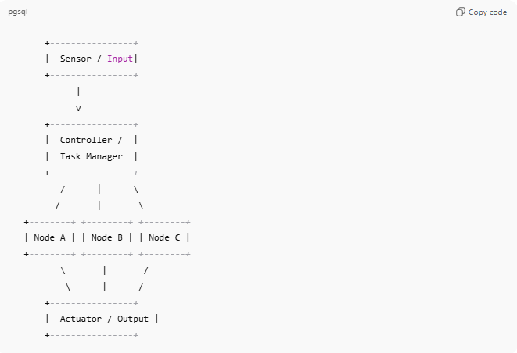
+----------------+
| Sensor / Input|
+----------------+
|
v
+----------------+
| Controller / |
| Task Manager |
+----------------+
/ | \
/ | \
+--------+ +--------+ +--------+
| Node A | | Node B | | Node C |
+--------+ +--------+ +--------+
\ | /
\ | /
+----------------+
| Actuator / Output |
+----------------+
- Sensors detect events or input data
- Nodes process events in a coordinated manner
- Actuators or outputs respond within real-time deadlines

Key Characteristics
# Source: AI Source: Provided by: [Data Path: Persons Table -> ID Column: 1, Name_En Column: Motasem Essam] -> From: [ChatGPT] on [1/16/2026]
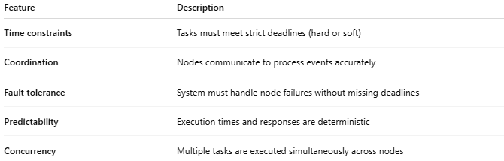
Feature | Description
Time constraints | Tasks must meet strict deadlines (hard or soft)
Coordination | Nodes communicate to process events accurately
Fault tolerance | System must handle node failures without missing deadlines
Predictability | Execution times and responses are deterministic
Concurrency | Multiple tasks are executed simultaneously across nodes

How It Works
# Source: AI Source: Provided by: [Data Path: Persons Table -> ID Column: 1, Name_En Column: Motasem Essam] -> From: [ChatGPT] on [1/16/2026]
- Sensors or external systems generate events
- Events are sent to processing nodes
- Nodes perform computations within deadlines
- Results trigger actuators or responses in real-time

Advantages
# Source: AI Source: Provided by: [Data Path: Persons Table -> ID Column: 1, Name_En Column: Motasem Essam] -> From: [ChatGPT] on [1/16/2026]
- Provides timely and predictable responses
- Fault-tolerant and reliable
- Can handle critical applications like aviation, healthcare, or industrial control
- Supports parallel event processing

Disadvantages
# Source: AI Source: Provided by: [Data Path: Persons Table -> ID Column: 1, Name_En Column: Motasem Essam] -> From: [ChatGPT] on [1/16/2026]
- Complex design and implementation
- Expensive hardware and software requirements
- Requires precise synchronization between nodes
- Network delays can affect system performance

Examples
# Source: AI Source: Provided by: [Data Path: Persons Table -> ID Column: 1, Name_En Column: Motasem Essam] -> From: [ChatGPT] on [1/16/2026]
- Air traffic control systems
- Automated industrial assembly lines
- Medical monitoring and life-support systems
- Autonomous vehicles (real-time sensor processing)
- Defense systems and missile control

Simple Analogy
# Source: AI Source: Provided by: [Data Path: Persons Table -> ID Column: 1, Name_En Column: Motasem Essam] -> From: [ChatGPT] on [1/16/2026]
- Distributed Real-Time System: An orchestra performing live
  - Each musician (node) plays their part simultaneously
  - Everyone must follow the conductor (coordinator) to stay on time
  - Missing a beat (deadline) affects the overall performance

